1. **Installation and configuration of Desktop Paravirtualization software on your Desktop.**
2. **Minimal installation of CentOS 7 or Ubuntu on the paravirtual software**
3. **Test internet access in the cli of guest VM**
4. **Update and upgrade latest version:**

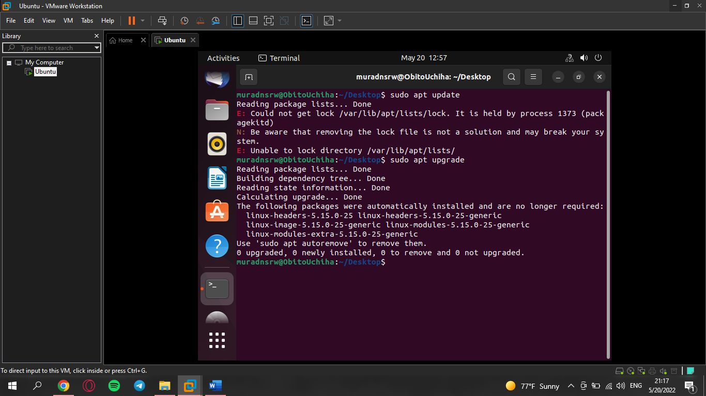

1. **Check status of firewall and take screen shoot of the cli output:**

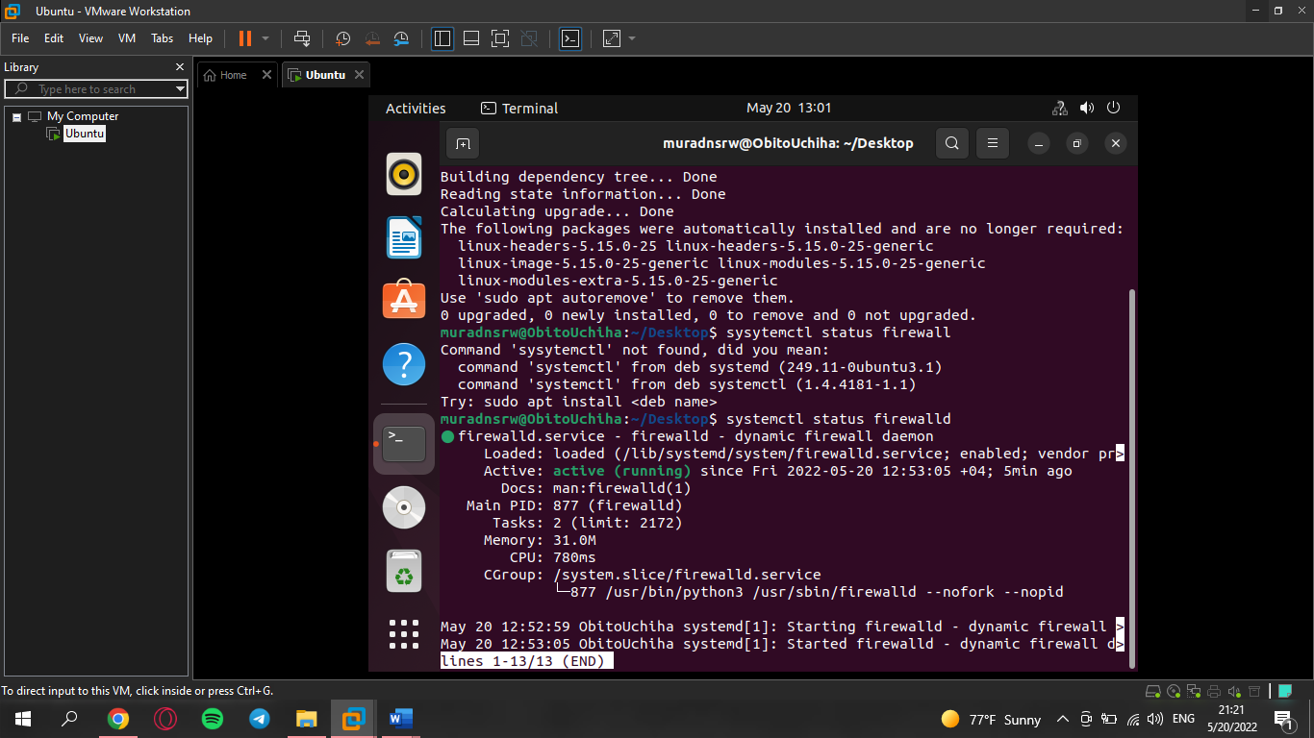

1. **To be check connectivity use commands:**

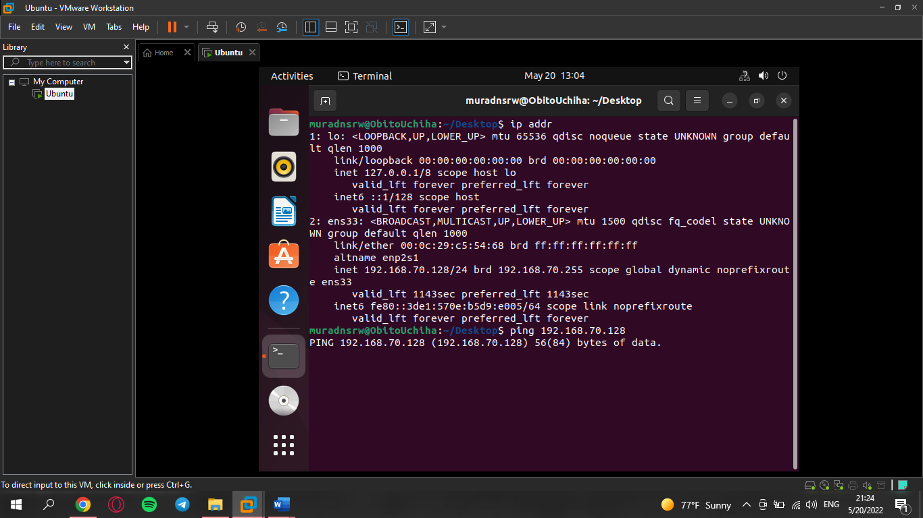**#ping**

1. **To be check SSH port status:**

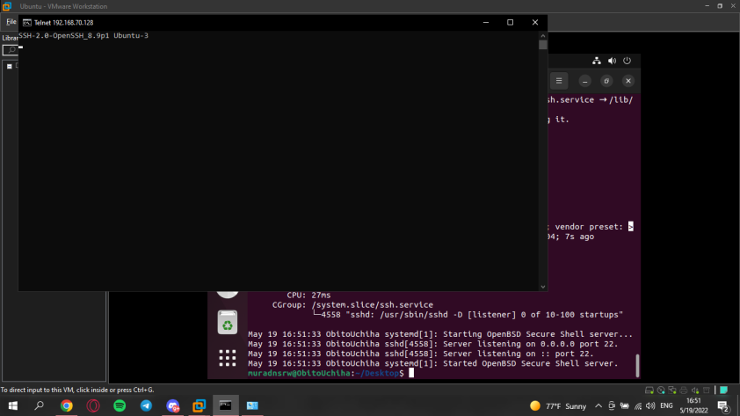

1. **Install SSH client application on your work environment:**

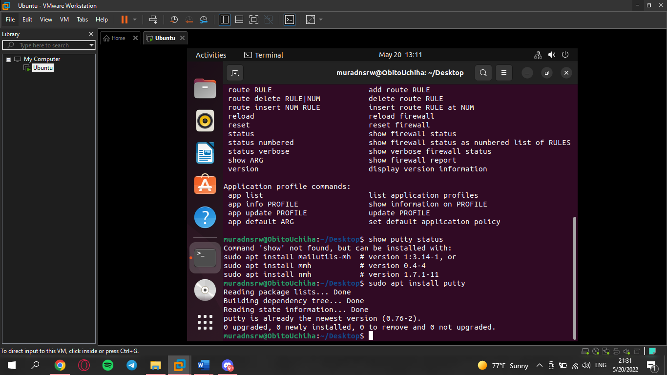

1. **Change host name to anything:**

